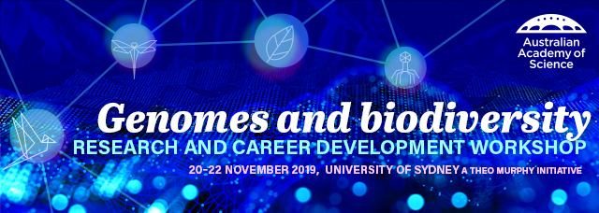Expressions of interest template form

Thank you for your interest in attending the Genomes and Biodiversity: Research and Career Development Workshop on 20 – 22 November 2019 at the University of Sydney. The event is supported by the Australian Academy of Science, through the Theo Murphy Initiative (Australia), the University of Sydney and the University of Copenhagen.
Please complete the expression of interest form for the opportunity to attend the event, present a short talk, and receive a mobility grant to support your attendance.
Applications close at midnight Monday 30 September 2019.
If you have any questions about your application, please contact us at emcr@science.org.au

Contact details
Title: ______________________________________
First name: _________________________________
Last name: _________________________________
Organisation: ______________________________________
Position: ______________________________________
Field of research: ______________________________________
Email address: ______________________________________
City/Town: ______________________________________
State/Territory: ______________________________________
Twitter handle: ______________________________________
Year PhD awarded: ____________________________________
If applicable, briefly describe any career interruptions: _____________________
Do you have any special dietary requirements? ___________________________

Details
Which one best describes your location?
☐I live in a metropolitan area | ☐I live in a regional area
Which of the following describes your research career stage?
☐Early career | ☐Mid-career
☐PhD student

Do you identify as an Aboriginal and/or Torres Strait Islander?
☐Yes | ☐No
☐Do not wish to answer

How do you describe your gender identity?
☐Female | ☐Male
☐Non-binary/Non-conforming | ☐Gender fluid
☐Other | ☐I do not wish to disclose

Event attendance
Describe how attending this workshop would be of benefit to you and your research? (max. 150 words)

Interested applicants are invited to apply to give a 10-min presentation about their research. Please be aware that there are limited spaces for talks. The organising committee will review and allocate presentations to aim for a diversity of research areas and speakers.
To be considered for a presentation spot enter your proposed talk title below.

As part of the event program, hands-on training workshops in analysis of big data from genomics and biodiversity will be available for attendees.
Please indicate which of the following workshops you would be interested to attend (up to 4):
☐Workflows for big data
☐Models in genomics and biodiversity analysis
☐Biodiversity of spatial analysis
☐Phylogenomics
☐Metagenomics and pathogen discovery
☐Genome-wide association studies

Support to attend
Through the Theo Murphy Initiative (Australia), the Australian Academy of Science is offering a number of mobility grants to support a diversity of EMCRs to attend the event.
The mobility grants are designed to offset the expenses associated with attending the event for those EMCRs who may not be able to attend without support and/or people from traditionally underrepresented demographics.
The mobility grants can be used to cover costs associated with attendance to the event, such as travel, accommodation, caring responsibilities and other support required to facilitate your attendance.
Would you like to apply for a mobility grant to support your attendance?
☐Yes
☐No

Please describe the circumstances that would make your attendance difficult without additional support (max. 150 words)

Please provide an estimate of your expenses

